# CS 255 System Design Document Template

This template lays out all the different sections that you need to complete for Project Two. Each section has guidance to prompt your thinking. You will need to continually reference the interview transcript as you work to make sure that you are addressing your client’s needs. There is no required length for the final document. Instead the goal is to complete each section based on what your client’s needs are. Remove this note when you are finished, and replace all bracketed text with the relevant information.

## UML Diagrams

### UML Use Case Diagram

### UML Activity Diagrams

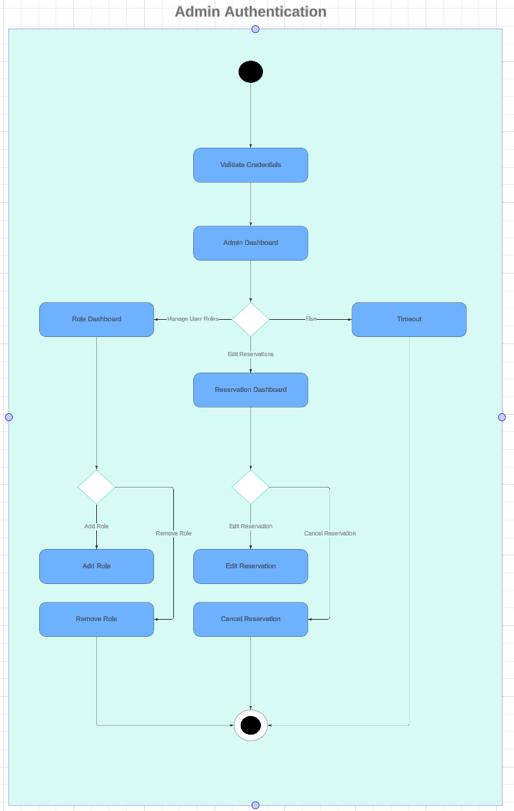

### UML Sequence Diagram

### UML Class Diagram

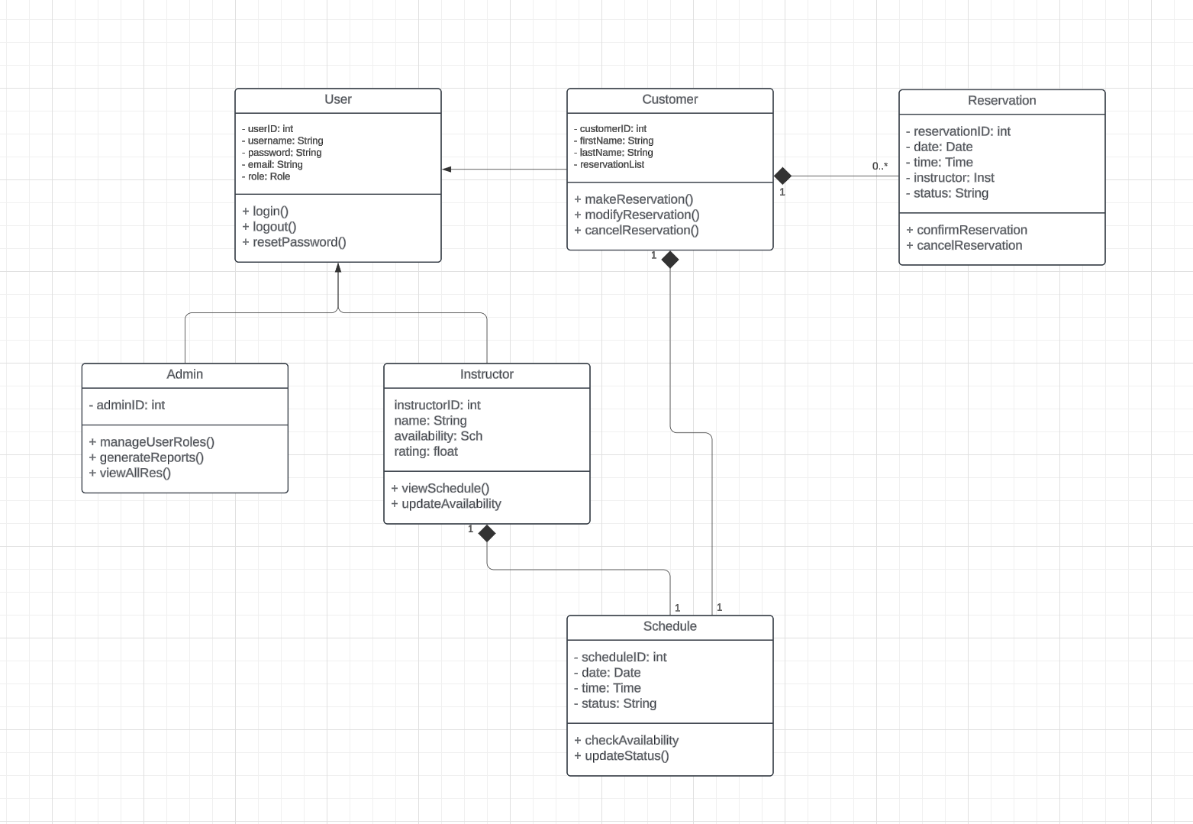

## Technical Requirements

*The tech requirements for the system encompass a wide range of hardware, software and infrastructure needed to ensure the functionality, performance and security. By using cloud based solutions, more modern dev frameworks and super robust security practices, the system will be equipped to meet the business needs of DriverPass. Some of these include but are not limited to AWS, EC2 or Azure, Linux Servers, Web servers like Apache, MySQL or PostgreSQL, and finally dev tools like visual studio, jetbrains softwares and github.*